Rajshahi University of Engineering & Technology
Department of Computer Science of Engineering

Experiment No: 03
Name of Experiment: Arrays, Records and Pointers

Submitted by:

Name: Md. Ariful Islam
Roll No.: 1803046
Group: 2nd Thirty
Date of Exp.: 16-09-2019
Date of sub. : 23-09-2019
Series: 18 Series

Submitted to:

Rizoan Toufiq
Assistant Professor
Department of Computer Science & Engineering
Rajshahi University of Engineering & Technology

Machine configuration:
ASUS X510UF
CORE I5 8th Gen Processor
Up To 3.4 GHz
8 GB RAM
OS WIN 10

INDEX

Preblem No. | Name of Problem
01. | Finding the Complexity of Bubble Sort
02. | Searching an element from an array by Linear Search
03. | Searching an element from an array by Binary Search
04. | Multiplication of Matrix
05. | <empty>
06. | <empty>
07. | <empty>
08 | <empty>
09 | <empty>
10. | <empty>

Theory: A Linear Array is a list of finite number n of Homogeneous data elements (i.e., data elements of the same type) such that:

1.The elements of the array are referenced respectively by an Index set consisting of n consecutive numbers.

2. The elements of the Array are stored respectively in successive memory locations.

The number n of elements is called the Length or Size of the Array.

In the lab we -
- Find the Complexity of Bubble Sort. In Bubble Sorting we can sort an array in Ascending or Descending order.
- Searched an element from an array by Linear Search. In Linear Search we check all the elements of an array one by one until we find out our searched data.
- Searched an element from an array by Binary Search. For binary search the Array must be Sorted. In Binary Search we check the elements of an array part by part by divideing the array in some condition.
- Multiplied two matrixes ( Matrix Multiplication).

Problem 1: Find the Complexity of the bubble Sort algorithm.

Flow Chart:
START

n: Length (A)

P
Swapped : 0
A[i-1] : A[i]
i 1

>
i : n-1
i++
Swapped:1
<= !=
<=
END
= =
Swapped : 1 0
>
goto P
Swap(A[i-1],A[i])
Algorithm:
(Given a nonempty array A with n numerical values. This algorithm sorts the values)
1. Set n := length(A)
2. swapped = false
3. Repeat i = 1 to n-1 by 1
4. If A[i-1]>A[i] then:
Swap (A[i-1], A[i]) and swapped = true.
[End of If Structure]
[End of Repeat 4 loop]
5. If swapped = true then:
Go to step 2
[End of If structure]
6. Exit

Code:

#include<stdio.h>

int main()

{

int A[]={43,21,67,98,76,47,23,12,69,55},n,i,j=0,temp,swapped,p;

n=sizeof(A)/4;

p: swapped=0;

for(i=1;i<n;i++)

{

if(A[i-1]>A[i])

{

temp=A[i-1];

A[i-1]=A[i];

A[i]=temp;

swapped=1;

}

}

if(swapped==1)

goto p;

return 0;

}

Complexity: The complexity of the above algorithm is O(n2). (Let c= 4)

Complexity Table:
n | f(n) | c*g(n)
0 | 3 | 0
5 | 16 | 50
10 | 164 | 200

Graph:
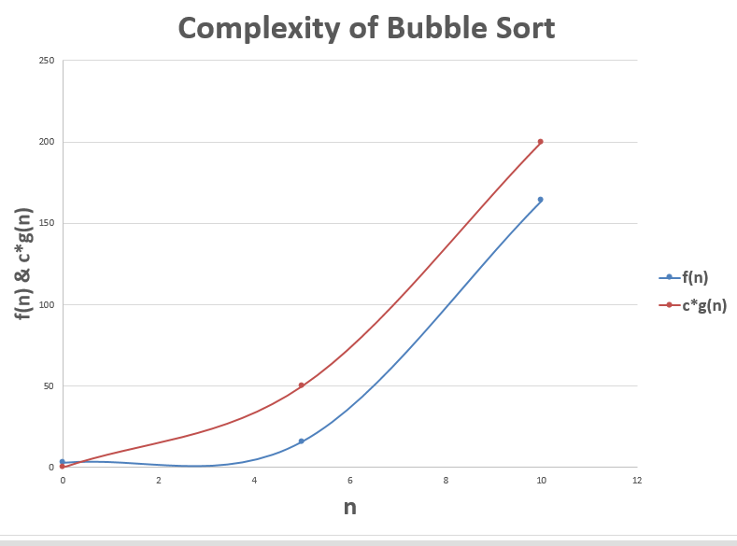

Problem 2: Linear Search from an Linear Array.

Flow Chart:

START

k : 0

LOC: -1

LOC= -1
&& k< n

yes no
k: k+1

X : A[k]
LOC: -1
!= !=

= = = =
LOC k+1

LOC is the location of X
X is not in the array A

END

Algorithm:
Given a nonempty array A with n numerical values and a specific x of information is given. This algorithm finds the location LOC of x in the array A or Sets LOC=-1)
1. Set K:=1, LOC:=-1
2. Repeat steps 3 and 4 while LOC = -1 and K≤n
3. IF x = A[K] then:
Set LOC:=K.
[End of If structure]
4. K:=K+1.
[End of step 2 loop]
5. If LOC = -1 then: Write: x is not in the array A.
Else: Write: LOC is the location of x
[End of If structure]
6. Exit

Code:
#include<stdio.h>

int main()
{
int A[]={43,21,67,98,76,47,23,12,69,55},x,k=0,n,loc=-1;
n=sizeof(A)/4;
scanf("%d",&x);
while(loc==-1&&k<n)
{
if(x==A[k])
loc=k+1;
k++;
}
if(loc==-1)
printf("%d is not in the Array\n",x);
else
printf("%d is the location of %d\n",loc,x);

return 0;

}

Complexity: The worst case complexity is C(n) =n when X is the last element of the array and the average case complexity is C(n) = (n+1)/2.

Problem 3: Binary Search from an Linear Array.

Flow Chart:

START

LB: 0
UB: N-1

MID : INT((LB+UB)/2)
LOC: -1

P

LOC= -1 &&
LB<=UB
yes no

< < >
X:A[MID]
LOC: -1
= =
END
X is not in the array A

= =
UB: MID-1
LB: MID+1
!=
LOC: MID+1

LOC is the location of X

MID : INT((LB+UB)/2)

P

Algorithm:
(Given a sorted array A with n numerical values and a specific x of information is given. This algorithm finds the location LOC of x in the array A or Sets LOC=-1)
1. Set LB:=1, UB:=n, MID = INT((LB+UP)/2) and LOC:=-1
2. Repeat steps 3 and 4 while LOC = -1 and LB≤UB
3. IF x < A[MID] then:
Set UB:=MID-1.
Else If x > A[MID] then:
Set LB:=MID+1.
Else:
Set LOC:=MID
[End of If structure]
4. MID = INT((LB+UP)/2).
[End of step 2 loop]
5. If LOC = -1 then: Write: x is not in the array A.
Else: Write: LOC is the location of x
[End of If structure]
6. Exit

Code:

#include<stdio.h>

int main()
{
int A[]={23,26,31,37,45,53,65,69,74,78,81,85,89,93,99};
int n,x,lb,ub,mid,loc=-1;

n=sizeof(A)/4;
lb=0; ub=n-1;
mid=(lb+ub)/2;
scanf("%d",&x);

while(loc==-1&&lb<=ub)
{
if(x<A[mid])
ub=mid-1;
else if(x>A[mid])
lb=mid+1;
else
loc=mid+1;
mid=(lb+ub)/2;
}
if(loc==-1)
printf("%d is not in the Array\n",x);
else
printf("%d is the location of %d\n",loc,x);

return 0;

}

Complexity:
After,
Loop 1 ----------- n / 2¹
Loop 2 ----------- n / 2²
Loop 3 ----------- n / 2³
.................................................................
.................................................................
After the last loop (say, k) there will be only one element in the arrey.
So after,
Loop k ----------- 1 = n / 2^{k}

As, 1 = n / 2^{k}
or, 2^{k} = n
or, log₂2^{k} = log₂ n
or, k log₂2 = log₂ n
or, k = log₂ n

So the complexity is O(log₂ n).
Problem 4: Multiplication of Matrix.

Flow Chart:
START

>=
I: M
I : 0
I++
X

<
END

J : N
C[I,J] = 0
J : 0
J++
J : P
K : 0
K++
>=
X
Y
<
<

>=
Y

>
C[I,J] = C[I,J] + A[I,K]*B[K,L]

Algorithm:
(Let A be an M × P matrix array and B be an P × N matrix array. This algorithm stores the product of A and B in an M×N matrix array C)
1. Repeat steps 2 to 4 for I = 1 to M:
2. Repeat steps 3 and 4 for J = 1 to N:
3. Set C[I,J]:=0.
4. Repeat for K = 1 to P: C[I,J] :=C[I,J] + A[I,K]*B[K,J].
[End of step 4 loop]
[End of step 2 loop]
[End of step 1 loop]
5. Exit

Code:

#include<stdio.h>

int main()
{
int A[3][2]={2,3,1,2,5,3},B[2][3]={1,4,2,3,1,3};
int C[3][3],i,j,k;

for(i=0;i<3;i++)
for(j=0;j<3;j++)
{
C[i][j]=0;
for(k=0;k<2;k++)
C[i][j]=C[i][j]+A[i][k]*B[k][j];
}

return 0;

}

Complexity: In the programe there is running 3 nested ‘for’ loop. We know each loop’s complexity is n. So for 3 nested for loop the complexity will be n*n*n = n³.

So the complexity is O(n³).

Discussion: The problems were based on Array. After trying sometime I had solved the problems.

The End

